Potential Color Palettes

# Sunset Palette

**Colors and their Hex**

#DEA193 – Rose Gold

[#6a0d83](https://www.color-hex.com/color/6a0d83) – fuchsia

[#ce4993](https://www.color-hex.com/color/ce4993) – Bubble Gum Pink

[#ee5d6c](https://www.color-hex.com/color/ee5d6c) - Salmon

[#eeaf61](https://www.color-hex.com/color/eeaf61) – Golden Yello

#517BCC – True Blue

#142E57 – Navy Blue

#FFFFFF – White

#000000 - Black

**Image inspiration**

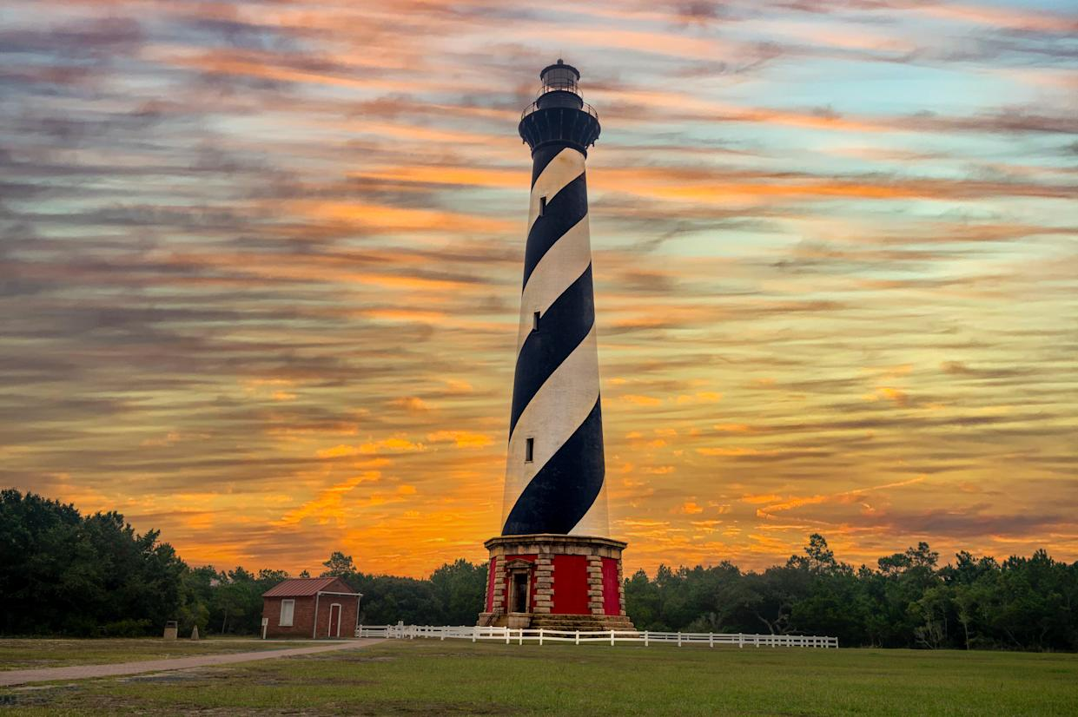

<https://www.google.com/url?sa=i&url=https%3A%2F%2Fcreators.yahoo.com%2Flifestyle%2Fstory%2Funforgettable-lighthouses-that-belong-on-your-travel-bucket-list-102750843.html&psig=AOvVaw2gizIG-Fv6JKbSex-q0YjN&ust=1743129191132000&source=images&cd=vfe&opi=89978449&ved=0CBUQjRxqFwoTCMi_ueSiqYwDFQAAAAAdAAAAABAE>

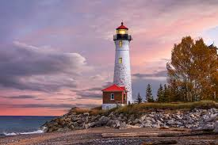

<https://www.google.com/url?sa=i&url=https%3A%2F%2Fwww.surfertoday.com%2Fenvironment%2Fwhat-is-a-lighthouse&psig=AOvVaw2gizIG-Fv6JKbSex-q0YjN&ust=1743129191132000&source=images&cd=vfe&opi=89978449&ved=0CBQQjRxqFwoTCMi_ueSiqYwDFQAAAAAdAAAAABAJ>

# Classic Sailor

**Colors and their Hex**

#FFFFFF – White

#000000 - Black

#142E57 – Navy Blue

#A60032 – Bright Red

#65CBF9 – Baby Blue

**Images Inspirations**

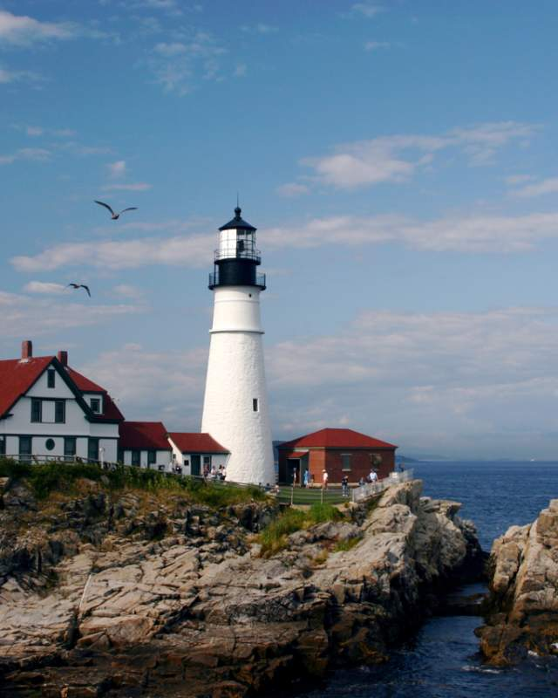

<https://www.google.com/url?sa=i&url=https%3A%2F%2Fwww.mainetourism.com%2Fthings-to-do%2Fattractions%2Flighthouses%2F&psig=AOvVaw2gizIG-Fv6JKbSex-q0YjN&ust=1743129191132000&source=images&cd=vfe&opi=89978449&ved=0CBQQjRxqFwoTCMi_ueSiqYwDFQAAAAAdAAAAABAS>

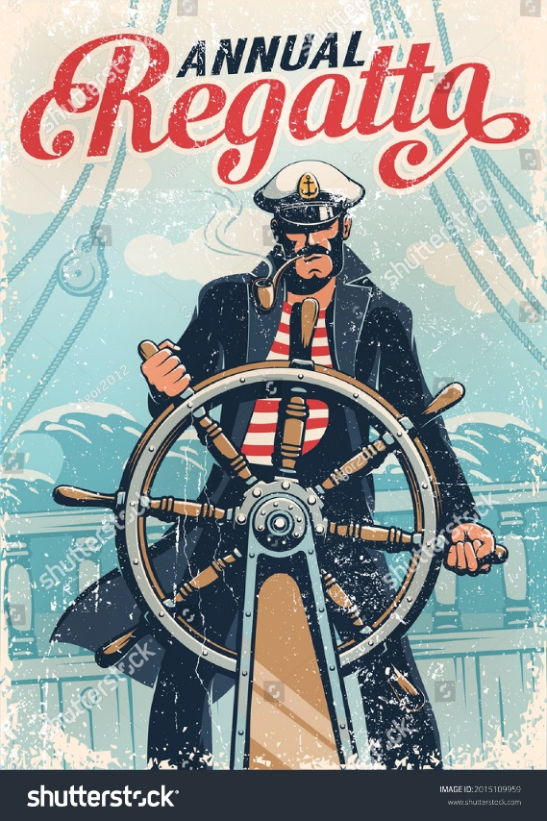

https://www.google.com/url?sa=i&url=https%3A%2F%2Fwww.shutterstock.com%2Fimage-vector%2Fcaptain-sailor-helm-ship-against-background-2015109959&psig=AOvVaw0E9wYnj0behobcCV3x54wd&ust=1743131203972000&source=images&cd=vfe&opi=89978449&ved=0CBQQjRxqFwoTCNimxvajqYwDFQAAAAAdAAAAABAJ